

**Image**

**Class**

**Xmin**

**Ymin**

**Xmax**

**Ymax**

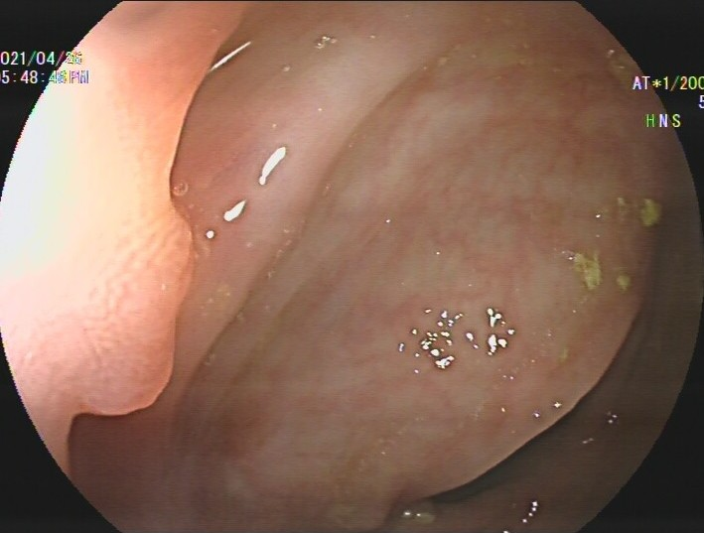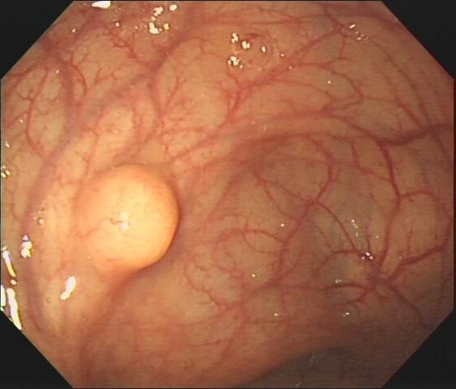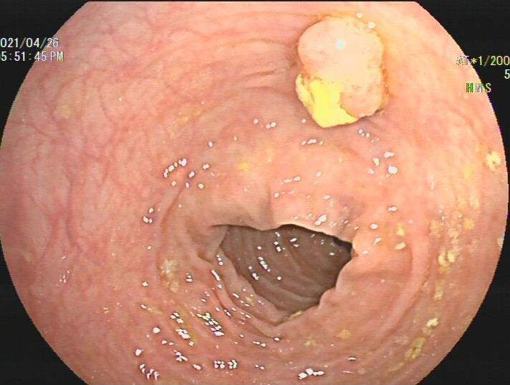

Box

Pedicle Pedicle Edge

415 97 72

17 200 206

540 224 199

166 336 419



**Polyp:67%**

**Polyp:73%**

**Polyp:61%**

**FSOD Model**

**Supervise**

340f206eec142a88be4ccdfab2575570

**Annotate**

**Train & Predict**

**（a）**



Pedicle Pedicle Edge



**Image**

**Class**



**Our Model**



**Pedicle:67%**

**Pedicle:73%**

**Edge:61%**

**（b）**

**Supervise**

**Train & Predict**

**Annotate**